TOOLS:

- Phillips head screwdriver
- 10mm socket
- Ratchet (and extensions if needed)

- Floor jack
- Wheel chocks
- Jack stands

Installer Note: There are many ways to install this kit. If you want to save time and frustration
take the wheels off. Turning the wheel does not provide sufficient room to work.

- Chock your wheels, raise the front of the car with the jack, place on jack stands and remove the wheels.

- Remove the fender liners.
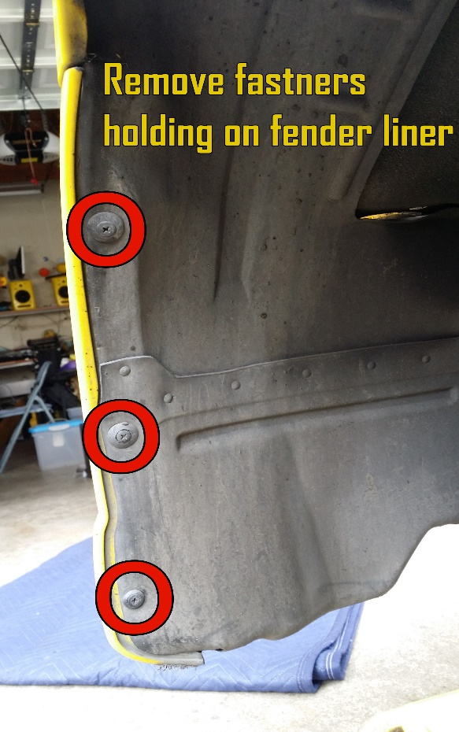
There are about 8 fasteners holding it in place (Figure 1). Some of these break when removed and are meant to be replaced. If you plan on just pulling the fender liner out of the way, take extra care not to break them. Also, some of the fasteners are meant to be replaced, not re-installed. If you have some like these you can pick some that will fit at your local parts place or you can get the Mazda ones at the dealer.
1

- Remove the two (2) factory bolts holding the front bumper to the fender.
With the fender liners now out of the way, you can access the two (2) bumper bolts, remove these bolts, repeat this step on the other side.
(Figure 2).
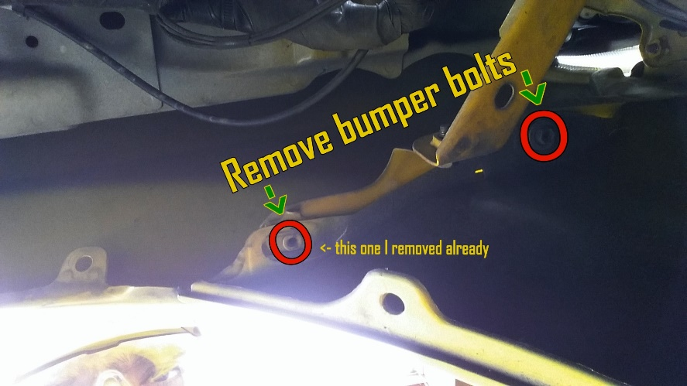
2

- Remove the two (2) top screws holding the bumper on along with any remaining bolts holding the bumper on

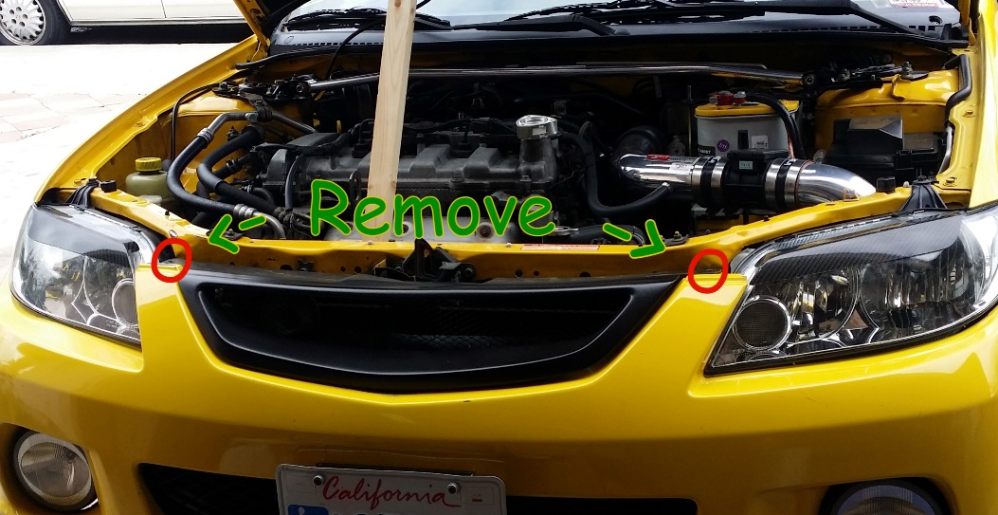
- Remove the bumper.
3
There are a few along the bottom front of the bumper (Figure 3).
*Be careful and disconnect the side markers and fog light harness if you have them. Remember the fog lights actually stay on the bumper when you remove it. There is only one connection you need to disconnect to pull the bumper and it is located on passenger side by the windshield washer water reservoir.

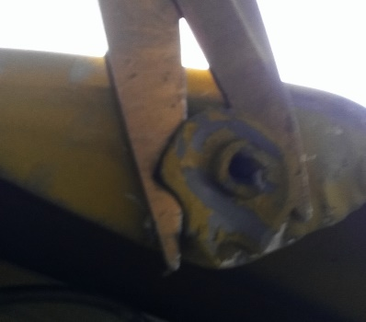
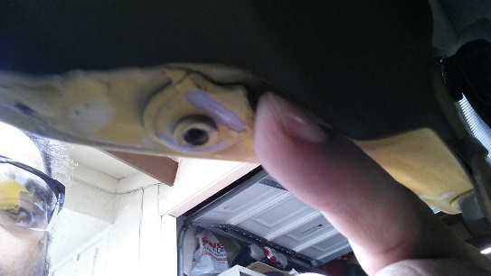
- Remove the plastic clips from the fenders (Figure 3).
4
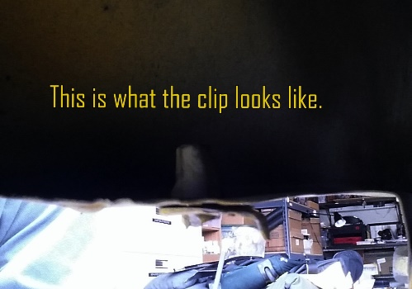
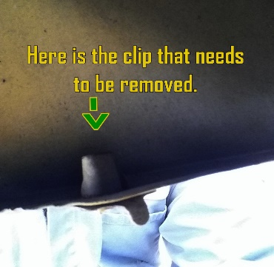
They are grey in color, unless they have been painted over (like mine). You can try twisting them off, however, it is easier to either drill them out or cut them with some heavy duty cutters.

- Reattach the bumper.
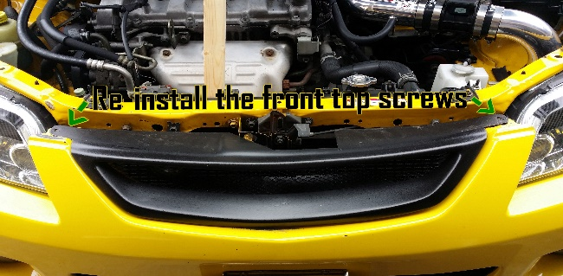
Use the two top screws to hold the bumper in place while install the brackets. (Figure 4)
4

Note: You can use the floor jack, or a friend to hold the bumper up in place while you line up the bumper with the fender while you install the brackets.

- Install the bracket.
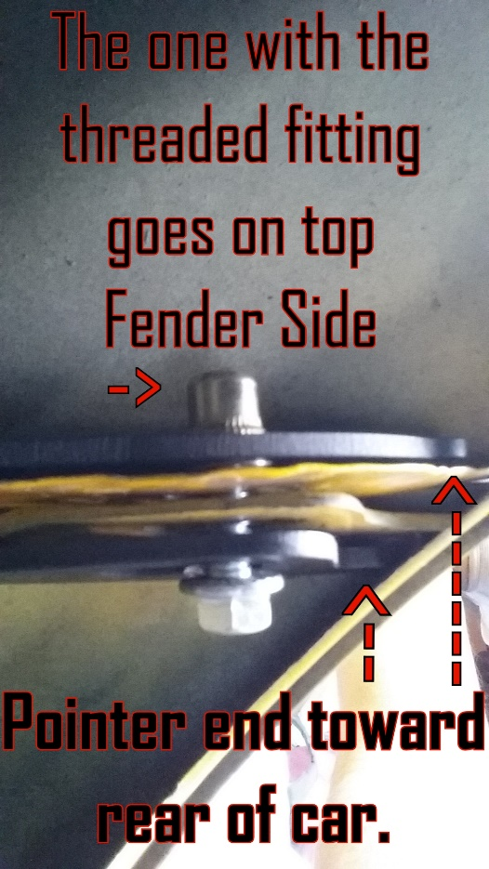
Figure 5 shows how the bracket should be positioned, with the pointed ends against the fender and bumper and facing the rear.
It is best to have it already lined up and the gap closed when installing the bracket.

- Line up and Tighten
Once it’s all lined up and looks good, go ahead and tighten it down.

Note: If your fenders and/or front bumpers have been replaced or damaged due to accident or if it is an aftermarket part. You may need to drill the fender holes to make them wider towards the inside of fender in order to better line up the SAP kit.
5
ENJOY THE RESULTS

